**Journey to the treasures of the Ba’al Shem Tov 22-29 April 2020**

*We are travelling through the land of the Ba’al Shem Tov in search of the remaining treasures. The journey takes us along the old Shtetls were in the past the Hasidic Rabbis were living and working. We will enjoy the nature were some Rabbis found their inspiration and we will visit old synagogues, a mikwe and cemeteries. The treasures can be found both indoors and outdoors at the places were the Rabbis have lived and worked.*

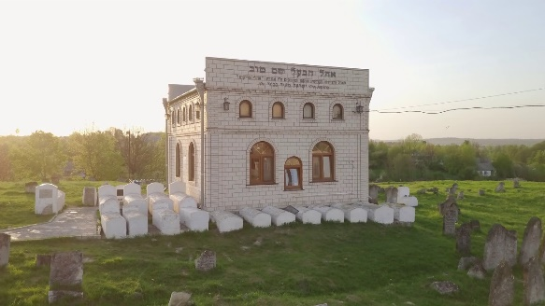

**Program:**

**Flight details:**

22 April 2020: Amsterdam 09.30 – Kiev 13.15  
29 April 2020: Kiev 14.00 – Amsterdam 16.00

**Wednesday 22 April: Day 1 – Kiev - Vinnytsia (200km)**At the airport in Kiev a bus with guide is waiting for the group. Via a panoramic route the bus will bring you to your hotel in Vinnytsia. A short lunch stop will be made.  
Before WWII Vinnytsia had a large Jewish Community. During the war almost the complete Jewish quarter ‘Yerusalimka’ has been destroyed. Upon arrival at hotel Rooms there will be a 3-course kosher style diner at the hotel. After diner a welcome and introduction meeting is planned.

**Thursday 23 April: Day 2­- Vinnytsia – Medzhybosch - Chmelnitsy (120 Km)**After breakfast and morning meditation you travel to Medzhybosch were you will first bring a visit to the Ohel of the Ba’al Shem Tov. In this Ohel lies Rabby Moshe Chaim Ephraim of Sudilkov as well. More background information can be found at the interesting bookstore which is located next to the Ohel. In the afternoon you will visit the Beit midrash Besht Synagoge, the mikwe and the Apter Synagoge. The bus will bring you to 3* hotel Tsentralniy in Chmelnitsy. In the evening you will enjoy a 3-course kosher style diner. After diner is an evening program.

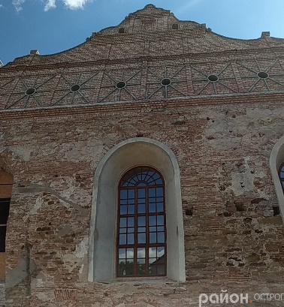**Friday 24 April: Day 3 – Chmelnitsy – Polonne – Rivne (240 km)**After breakfast and morning meditation you travel to Polonne. The history of Polonne goes back to the year 996. In the Middle Ages this city was known for its castle. From 1648 there has been a large jewish community. You will visit the Ohel and the cemetery of Rabby Yaakov Yosef and in the afternoon the Synagoge and the museum. The bus will bring you to Mir hotel Rivne for your 4 nights stay. Upon arrival a Synagoge service followed by a Shabbat diner will be offerred.

**Saturday 25 April: Day 4 - Rivne**

After breakfast this day is all about lernen and meditation in the woods.  
After diner the evening program will be mainly about Rabby Yaakov Yosef.

**Sunday 26 April: Day 5 – Rivne Hannopil – Rivne**After breakfast there will be an explanation about the history of Hannopil. Since 1770 Hannopil plays an important role to the Hasidic community. The remaining monuments are graves from the Maggid Dov Ber from Mezrich and Reb Zusha. The graves from Dov Ber and his disciple Reb Zusha have been destroyed by vandals during the 2nd World War. Both graves are being visited a lot by Hasidic jews. In the afternoon you will visit the Ohel and the cemetery. At the lake it is time to lern. After diner the evening program will be mostly about Rabbi Pinchas of Koretz.

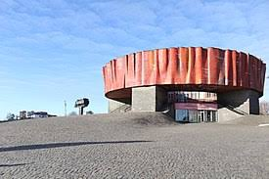**Monday 27 April: Day 6 – Rivne – Shepetivka – Rivne**

After breakfast and morning meditation the bus will bring you to Shepetivka. Shepetivka has always been very important for the Jewish community. Between 1670 and 1760 the number of jews increased from 20.000 to 52.000. Around 1700 several important Rabbis were active in this region, for instance Rabbi Pinchas Shapira van Koretz who is buried in Shepetivka. You will visit the old cemetery and the synagoge. In the afternoon you will visit the new cemetery. After diner is an evening program.

**Tuesday 28 April: Day 7 – Rivne – Kiev (330 km)**After breakfast and morning meditation you will check out and the bus will bring you to Kiev. In Kiev you will visit the jewish sights, The bus will bring you to the Ukraina hotel in Kiev for your farewell dinner. During the evening program there will be some reflection about the journey.

**Wednesday 29 April: Day 8 – Kiev – Amsterdam**

Today is the last day. You check out and the bus will bring you to the airport for your flight back to Amsterdam.

.

**Price** including return flight Amsterdam to Kiev, 23 kilo luggage,7 nights stay with breakfast and diner, bus with guide and program as written above

15-19 participants: € 1824,00

Single room surcharge € 175,00

*Minimum 15* participants

Prices above are valid until 7 December 2019. After 1 January 2020 prices will go up.